

MYHEIN USER’S GUIDE


LEARN HOW TO:

- Create and access your MyHein account

- Create and access bookmarks
- Organize, delete, or edit notes on bookmarks
- Export saved bookmarks
- Save and use search queries
- Set up eTOC alerts
- Use MyHein with Fastcase

1. CREATE AND ACCESS YOUR MYHEIN ACCOUNT

To create an account, click on the MyHein tab that is always located on the top bar of the screen:

Located on the Top Bar
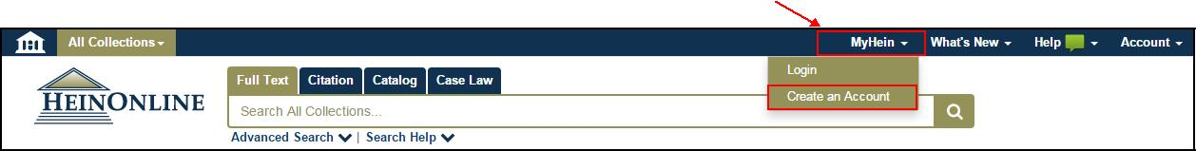

After creating your account, you will receive an e-mail confirming your username and password.

To access your MyHein account, you must be logged into your institution’s HeinOnline account. Enter your username and password from the MyHein tab.

2. CREATE AND ACCESS BOOKMARKS

Bookmarks can be created from search results or from inside a document. From search results, click Save to MyHein from an individual result, or select several results to save them all at once. To save from inside a document, click the blue bookmark:
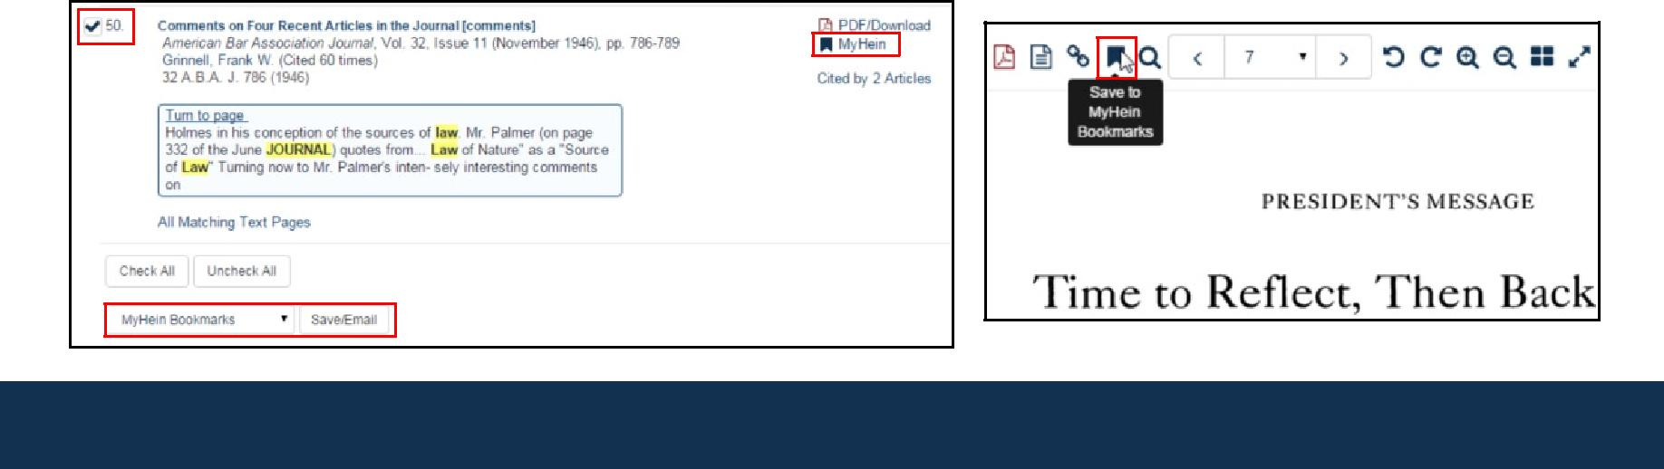
To access saved bookmarks, click the MyHein tab and choose Saved Bookmarks:
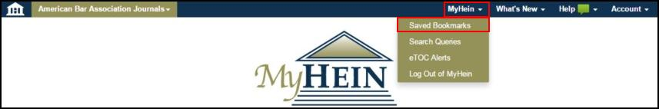

This will reveal a list of your saved bookmarks:
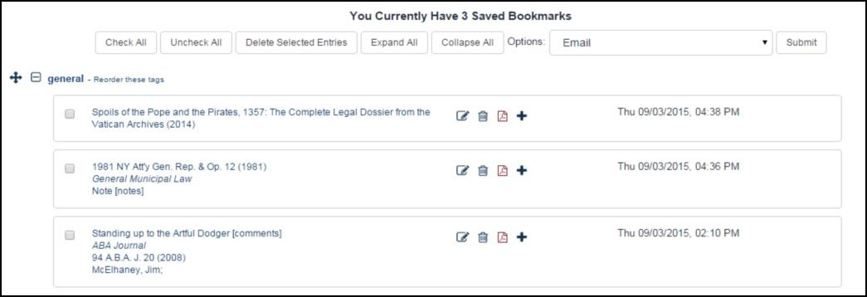

3. ORGANIZE, DELETE OR EDIT NOTES ON BOOKMARKS

Click Reorder This Tag to enable the bookmark moving tool and rearrange the bookmarks to your preference. Click Edit to change the tag under which the bookmark resides. Delete will remove the bookmark, and Add/Edit Note will allow notes to be added/changed to bookmarks.
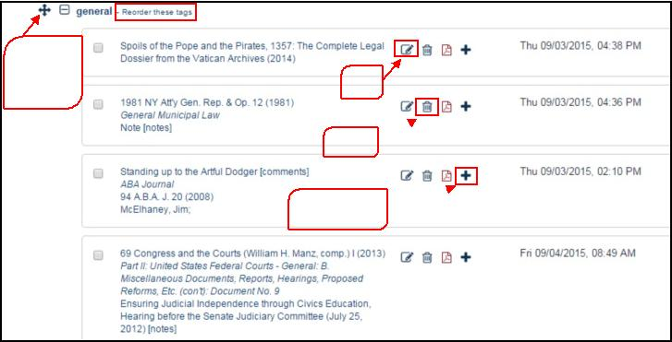

This tool
will move
Edit
bookmarks

Delete 

Add/Edit Note

4. EXPORT SAVED BOOKMARKS

Four export options are available on the Bookmarks Menu for exporting your saved research:

- E-mail

- Export to CSV
- Export to RefWorks
- Export to EndNote
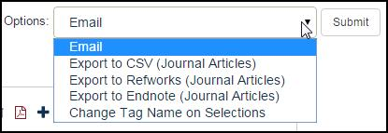
Note that the CSV, RefWorks, and EndNote options are only available with journal articles.
Email

Check the box next to one or more bookmarks to e-mail. Choose the E-mail option from the drop down menu at the top of the screen and click Submit.

Export to a CSV

This feature works with Law Journals only. Check the box next to one or more bookmarks that you would like to export to the CSV file. Choose the Export to CSV option from the drop down menu at the top of the screen and click Submit. You will then be prompted to open or save the CSV file.

Export to RefWorks or EndNote

This feature works with Law Journals only. Check the box for one or more bookmarks that you would like to export to RefWorks or EndNote. Choose the appropriate export option from the drop down menu and click Submit.

5. SAVE AND USE SEARCH QUERIES

To create a search query, run a search for your desired terms/phrases. Scroll to the bottom of the search results and select MyHein Search Queries. Next, choose an existing tag or create a new one.

Once a search query is saved, you will receive e-mailed lists of new material added to HeinOnline each month that meets the criteria of your query. In order to stop receiving the e-mail alerts, the search query must be deleted.
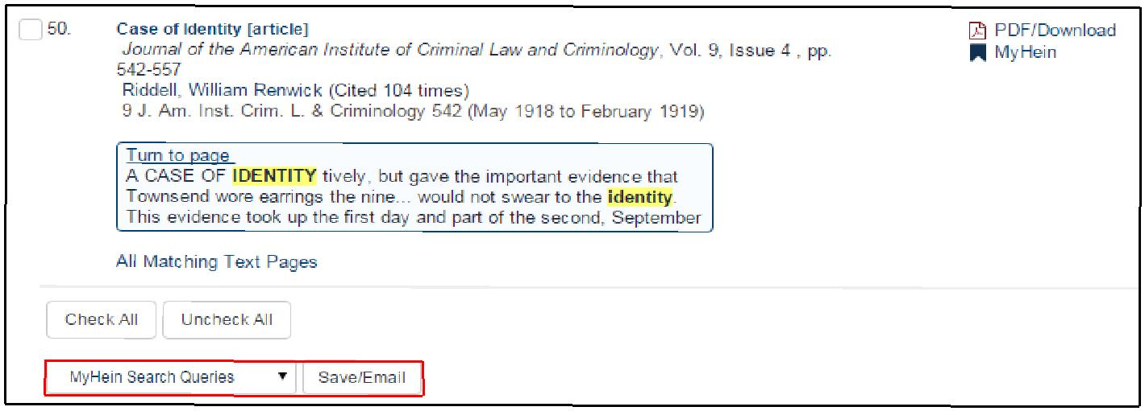

Click on Search Queries from the MyHein menu to view a list of search queries saved to date. Search queries are organized by tags. Each saved search query displays the search string as well as the library in which the search was run.
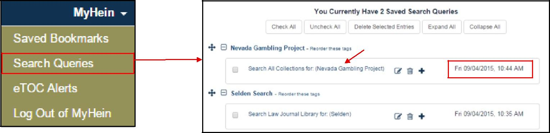

Search string and query terms

MYHEIN USER’S GUIDE | 

6. SET UP ETOC ALERTS

Create an electronic table of contents (eTOC) alert for one or more titles in order to receive an e-mail alert every time the selected titles are updated in HeinOnline. Browse to the desired title and click Create an eTOC Alert.
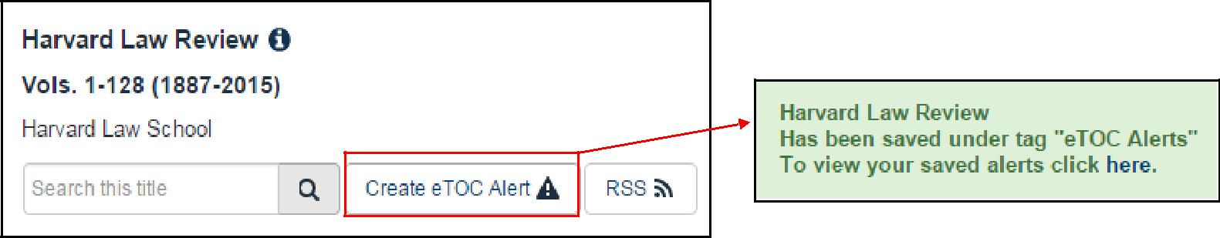

To view saved alerts, click on eTOC Alerts from the MyHein menu. You can add notes to alerts; you can also delete alerts that you no longer wish to receive.

7. USE MYHEIN WITH FASTCASE

Users of Case Law powered by Fastcase in HeinOnline can bookmark cases using MyHein. Look for the Save to MyHein link from inside the case or in search results.
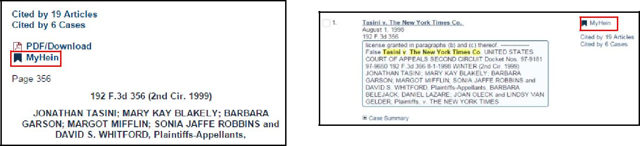

Select an existing bookmark name or enter a new one and click Save to MyHein Bookmarks. Case law will be saved just like other HeinOnline material.


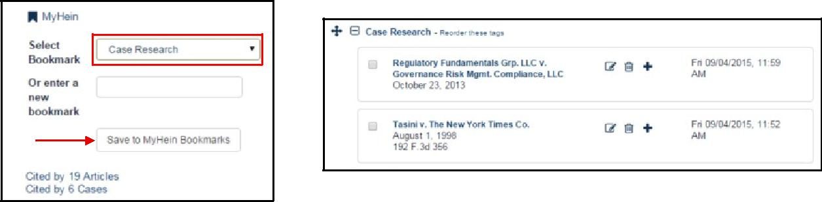



Tổng:
760 từ : 350 từ/trang = 2.17 trang

HeinOnline, a product of William S. Hein & Co., Inc. 2350 North Forest Road Getzville, NY 14068 (800) 277-6995 | holsupport@wshein.com

