  HEINONLINE |  | United Nations Law Collection
 |  | Q u i c k R e f e r e n c e G u i d e

1

Where do you start?

The Collection Home Page for this library displays prominent browse options, giving the option to browse by: All Titles, Treaty Publications, International Court of Justice, UN Commission on International Trade Law, International Tribunal for the Law of the Sea, UN Yearbooks, UN Serials, Codification and Progressive Development for International Law, and Other Related Works.
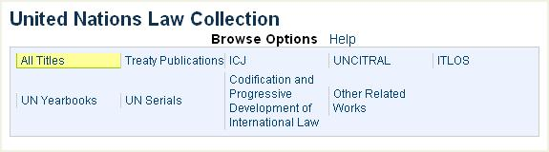
There are 5 different Finding Aids available that allow you to quickly pull up a citation, search for a treaty, search all UN publications or view international agreements by popular name. The Finding Aids can be found when browsing by All Titles in the collection.


2


3

Enter a UNTS or L.N.T.S. Citation:
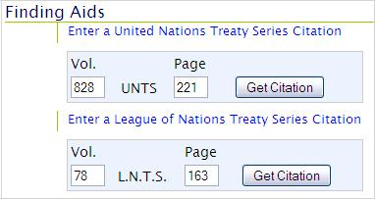
If you have a UNTS or L.N.T.S. citation, you can quickly enter the citation into the citation tool to access the full text of the treaty. When you click on the link, the tool will be displayed. For example, you can quickly locate 828 UNTS 221 or 78 L.NT.S. 163.
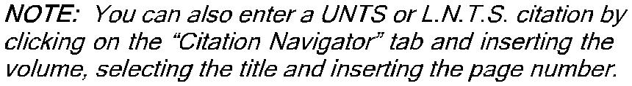

View International Agreements by Popular Name:
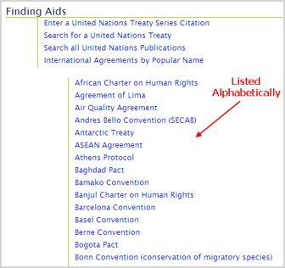
This list will display a number of well known International Agreements or Treaties by Popular Name. For example, the Berne Convention, Warsaw Treaty, and African Charter on Human Rights to name a few. To view the full list of agreements, simply click on the link and the list will expand. Click on any popular name and a search will generate displaying all treaties that are directly related to that international agreement. For example, if you click on Basel Convention, you will get a list of 5 UN Treaties that are directly related to the Basel Convention.

4 Search for a United Nations or a League of Nations Treaty:

Using the treaty search option, you can search across a number of different metadata fields for a UN or a League of Nations Treaty. The search option allows you to narrow your search to only UN, only League of Nations, or both treaty types.

Search only U.N.T.S., only L.N.T.S. or both treaty series.
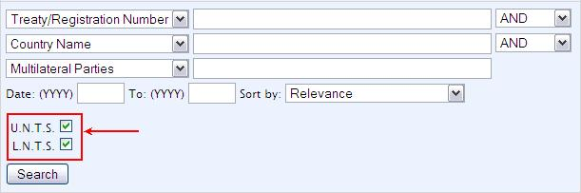


5 Search for a United Nations or League of Nations Treaty:
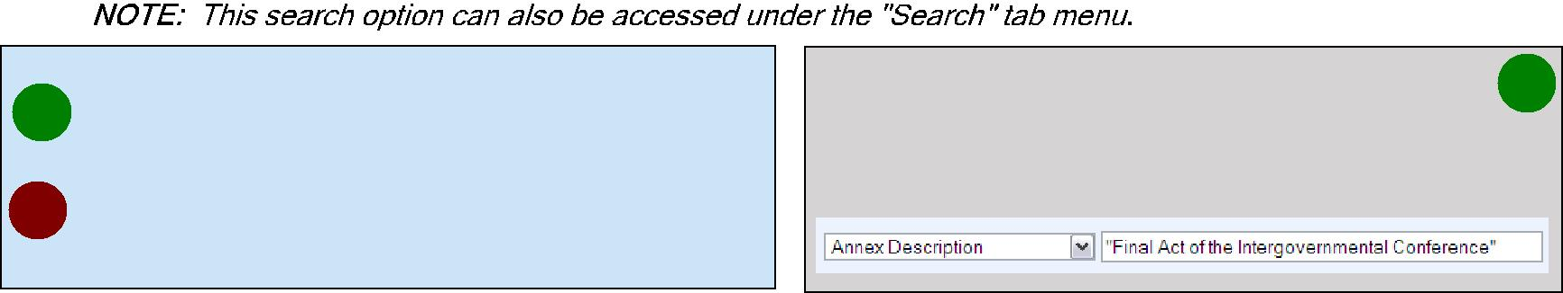

_{UNTS} This denotes a field that is searchable when looking for a UN Treaty.

_{LNTS} This denotes a field that is searchable when looking for a League of Nations Treaty.
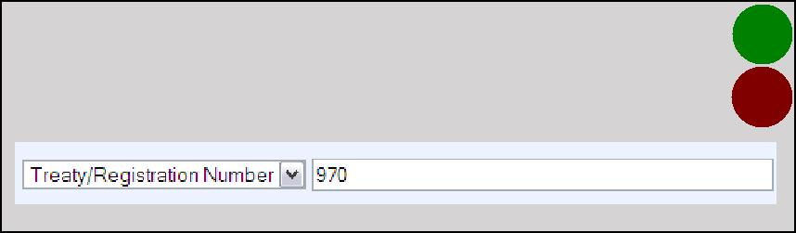

By Treaty/Registration Number: _{UNTS}

Enter the treaty number using the numerical digits
only. Example, I. No. 970 would be entered as “970” ^{LNTS}

By Annex Description: ^{UNTS}

Search across the Annex Description using key words. For example, “Final Act of the Intergovernmental Conference”.
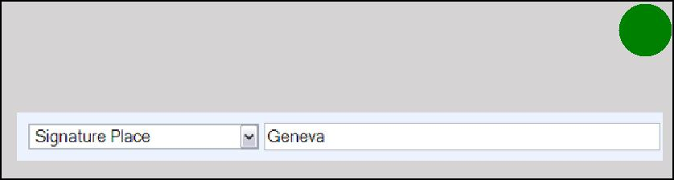

By Signature Place: _{UNTS}

Search by the place that the treaty was signed. For example, Geneva.
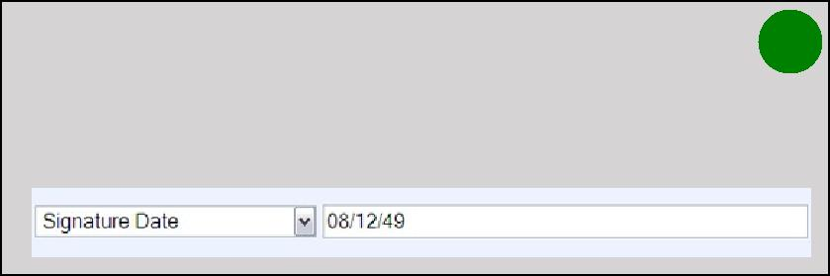

By Country Name:
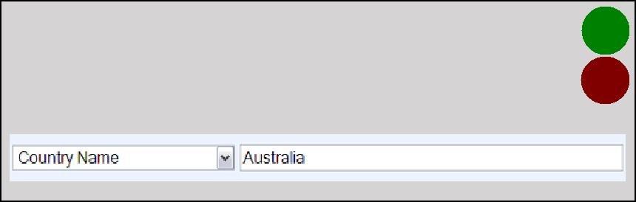

UNTS

By Signature, In Force, Previous Signature, or _{UNTS} Post Signature Date:

Search for a treaty by Country Name by entering the full country name into the search box, for ^{LNTS} example, Australia.
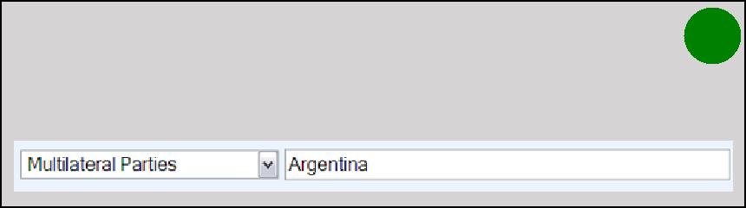
Search for a treaty by date using the following format: MM/DD/YY. For example, 08/12/49.
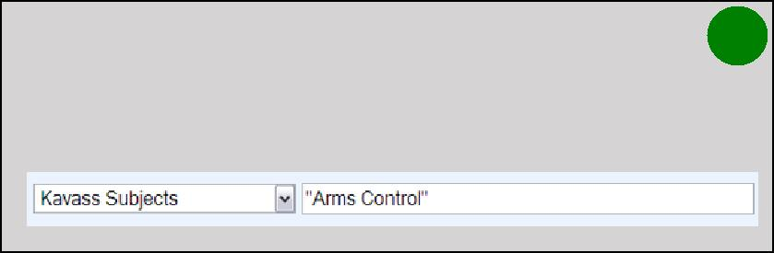

By Multilateral Parties: UNTS

Search by the multilateral parties involved in a treaty. For example, Argentina.
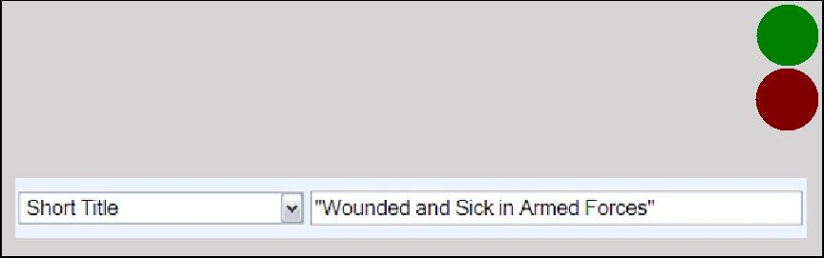

By Kavass Subjects: UNTS

All UN Treaties in HeinOnline have been assigned a Kavass Subject, thus allowing you to search by subject. For example, Arms Control.

By Short Title: ^{UNTS}

Search across the short title of the treaty using key _{LNTS} words. For example, “Wounded and Sick in Armed Forces”.

By UNTS Citation: _{UNTS}
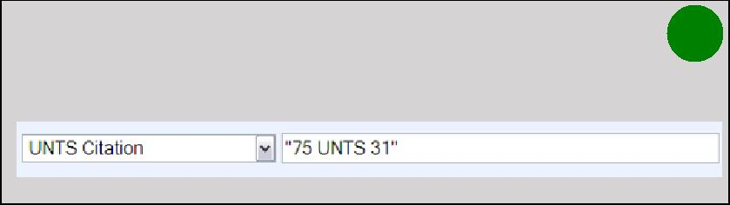
Search for a treaty by the UNTS citation. For example, 75 UNTS 31.
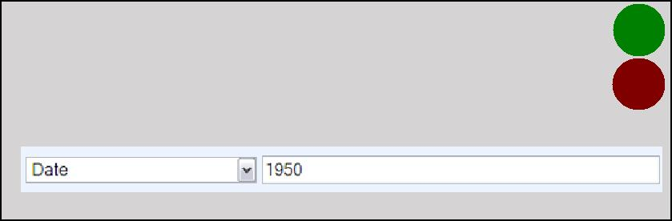

By Popular Name: ^{UNTS}
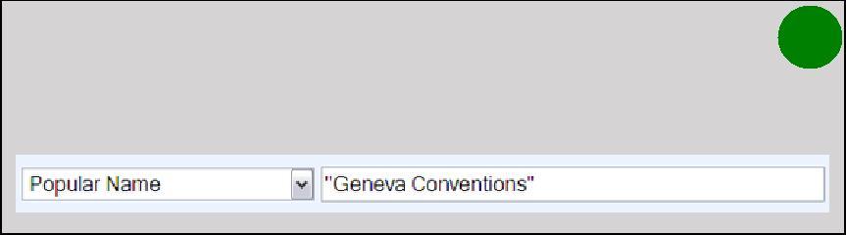
Search for a treaty by the popular name, for example, Geneva Conventions.
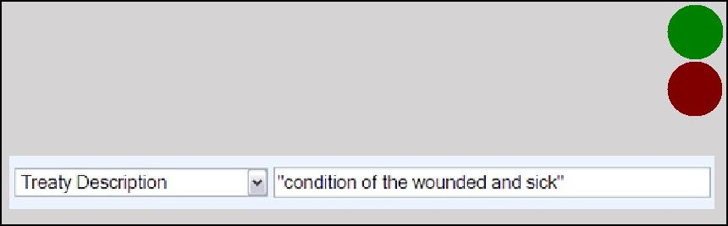

Date:

Search for a treaty by the UNTS volume date that the treaty was published in. For example, search for all treaties published in the UNTS in 1950.

UNTS

LNTS

By Treaty Description: _{UNTS}

Search for a treaty using key words from the treaty description. For example, “condition of the wounded ^{LNTS} and sick”.

Text:
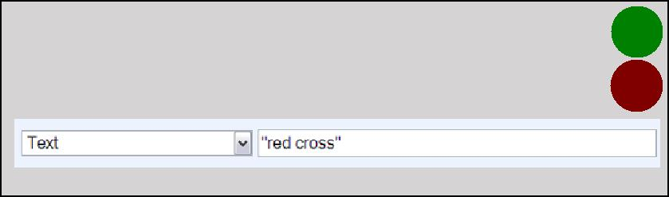
Search for a word or phrase among the full text of the treaty or treaties.

UNTS

LNTS

HEINONLINE

6 How to Read & Use the Search Results for United Nations Treaties:
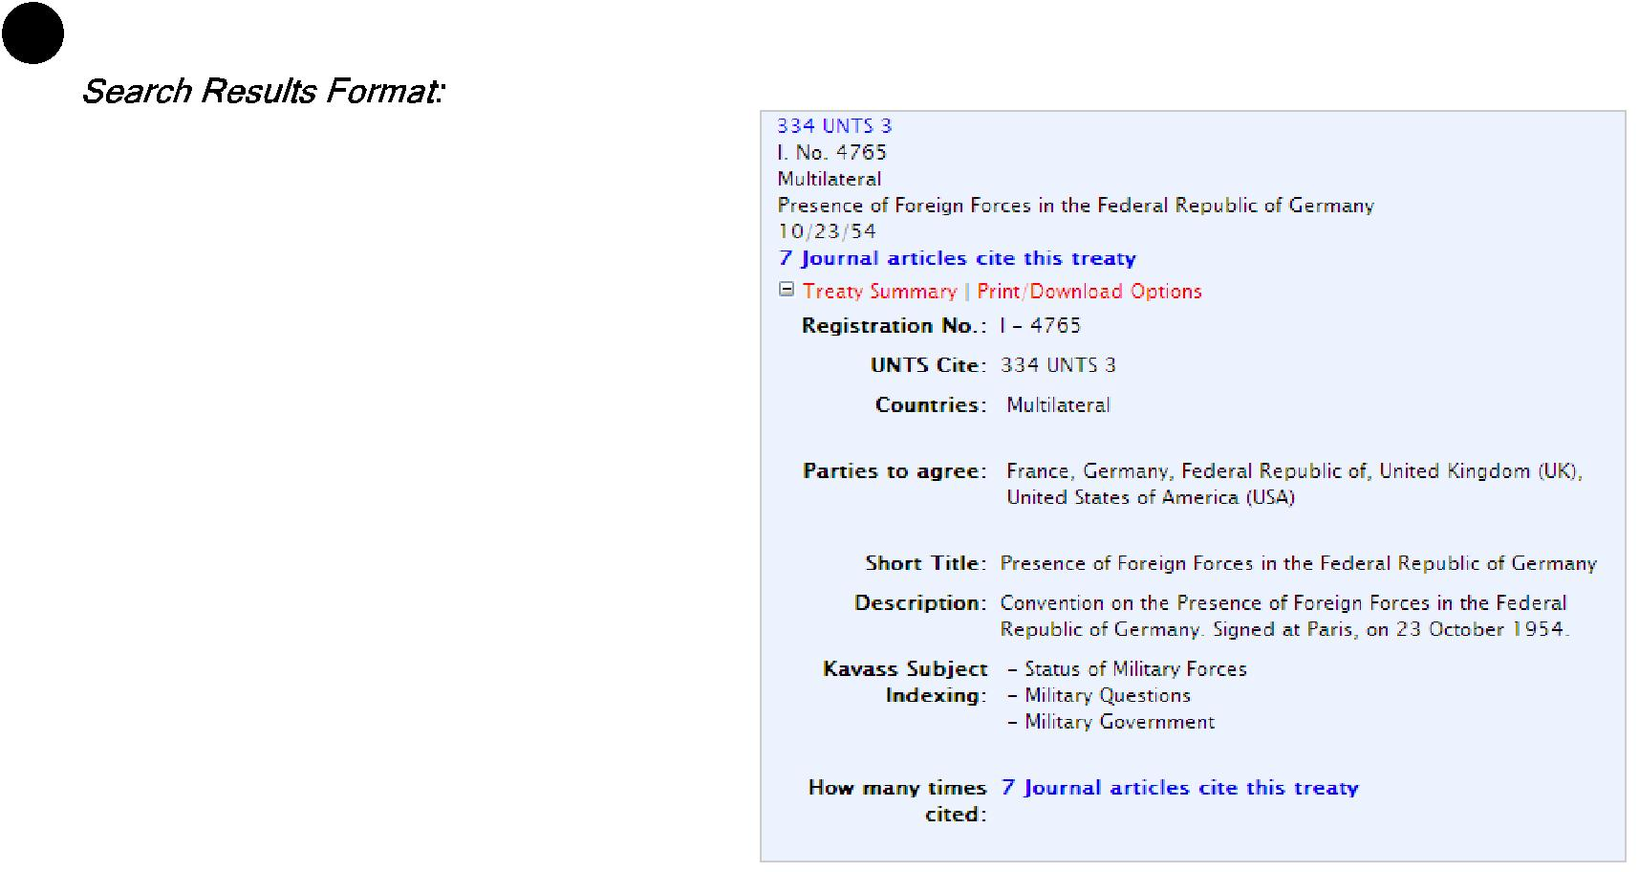

When you run a search for a United Nations Treaty, the search results will contain key information about the treaty including the:

- UNTS Citation - this links to the full text of the treaty

- Treaty/Registration Number
- Countries Involved or “Multilateral”
- Short Title
- Signing Date


If a link appears that says “[#] Journal articles cite this treaty”, you can click on the link to view a list of all Law Review articles in HeinOnline that cite this UN treaty.
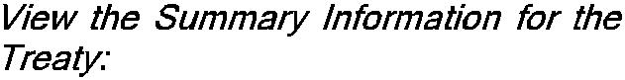

If you click on “Treaty Summary”, a list of key information about the treaty will be displayed. In addition to the above information outlined,

the Summary will also display the parties to agree (when applicable), the popular name, the full treaty description, as well as the Kavass subject indexing that is applied to the treaty.

If you see a result that begins with the heading *Agreement Text Not Currently Available*, this indicates that the full text for the agreement is not available in HeinOnline. We do however, still supply you with the data that is relevant to the treaty by allowing you to view the “Treaty Summary”.

7 How to Read the Search Results for League of Nations Treaties:
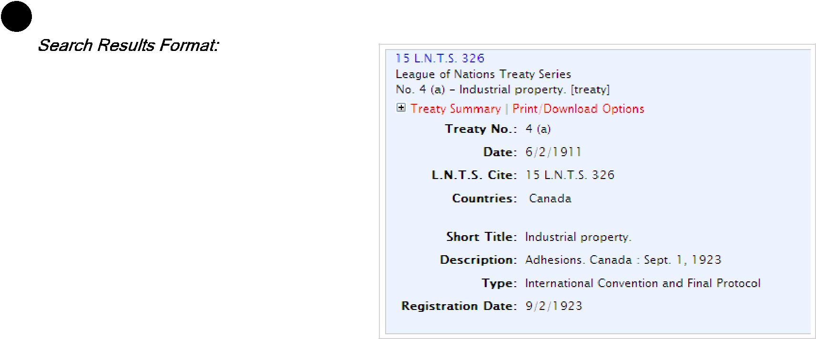

When you run a search for a League of Nations Treaty, the search results will contain key information about the treaty including the:

- LNTS Citation - this links to the full text of the treaty

- Treaty Number

- Short Title
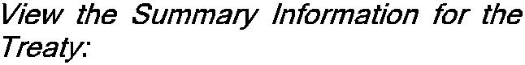

If you click on “Treaty Summary”, a list of key information about the treaty will be displayed. In addition to the above information outlined, the Summary will also display the date, countries involved or parties to agree (when applicable), description, treaty type, and registration date.

HEINONLINE

⁸ Search Across all United Nations Publications:
You can also choose to search across all the United Nations Publications that are available in this library. To do this, you can click on the link from the Collection Home Page as illustrated in #1 of this guide. Or you can click on the Search tab, and choose either a Field or Advanced Search as you would in other HeinOnline libraries. Once you’ve opened the search option, you can search across the Title, Description, Date or Text of the publications.

By Title:

The 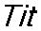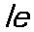field is reserved for the title of specific sections within the documents vs. the volume title. This allows you to drill down and
search for a specific section within a volume. Example: Delimitation of the Territorial Sea” that appears within the name and select from the drop down menu.

There is a section called “Status, Breadth and 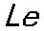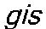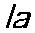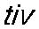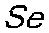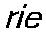set. Insert the title
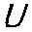

By Description:
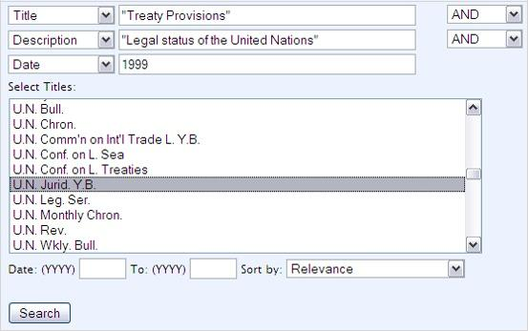
Each section or document also has a description. The description is displayed in when you look at the Table of Contents for a volume. For example, if we want to find the Treaty Provisions section from the 1999

volume of the United Nations Juridical Yearbook, we can search for “Treaty Provisions” in the title, and narrow our search to the
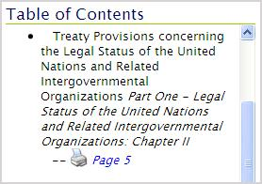
of this section, which is “Legal Status of the United Nations”.

By Date:

You can search across the volume date of a United Nations publication using the field from the drop down menu. The volume date will always be in the YYYY format. As illustrated in the above example, if you want to narrow your search to a specific section within a specific volume of the , you can insert the year, such as 1999, and choose from the drop down menu.
By Text:
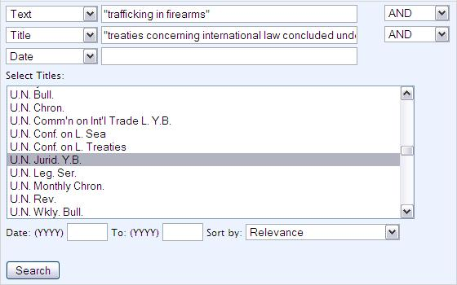
You can also search across the full text of all titles or a selection of titles in the United Nations Library. For example, you can search for references to “trafficking in firearms” in the 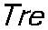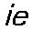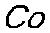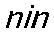
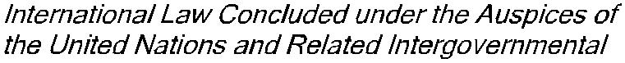

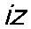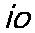 section of the United Nations
Juridical Yearbook.

Tổng: 1330 từ : 350 từ/trang = 3.8 trang

HEINONLINE

