
HEINONLINE

Browse by Country/State/Subject

The browse by options can be accessed from the Resources tab in the left menu or from the top of the collection home page. Browsing by U.S. State will display a list of each state and the corresponding titles published within. To view a list of all titles published in a specific country, use Browse by Country. Browse by Subject will display more than 80 subjects that have been coded to the journal title level. A journal title can be classified into multiple subjects.
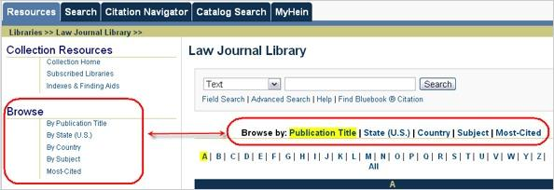

When searching by subject, you can choose one or multiple subjects to search across. If you choose more than one subject, the query will look for the term across all titles associated with subject 1 OR all titles associated with subject 2. For example, if you click on Accounting, three titles will be displayed in the title listing. Now, while holding down the CTRL key, click on Advocacy. The title listing now expands to 11 titles, 8 advocacy related titles and 3 accounting related titles. Thus, selecting multiple subjects expands your search rather than narrows it.



To search by country using the Field Search option, insert the full name of the country into the first search box, such as Australia, and select country from the drop down menu.
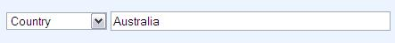

Search Options


There are some general rules applied to these search options. You can choose to search across the entire collection, or you can narrow your search to search by subject OR by title. These search options do not allow you to search across a specific subject AND across a specific title.

- If you select a subject, the titles associated with the subject will be displayed in the title listing. However, the titles will be grayed out, meaning you are unable to click on a title.

- To search across one or more titles, “All Subjects” must be highlighted from the subject listing. This will enable you to select specific titles.

- To reset search parameters, highlight either All Titles or All Subjects from within the search list you are using. This will re-enable the search functionality for the other list.

To search by country using the Advanced Search option, use the field name “country” and insert the full name of the Country.


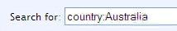

To search by state using the Field Search option, insert the full name of the State into the first search box (do not use abbreviations), such as New York, and select State from the drop down menu.
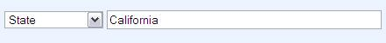

To search by state using the Advanced Search option, use the field name “state” and insert the full name of the State.
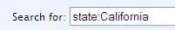


HEINONLINE

Search Examples

In each of the examples below, we are searching across “All Titles”. Therefore, this part of the search screen is not illustrated.

Search for the phrase “information security” across just California journals that are related to Business/Economics.
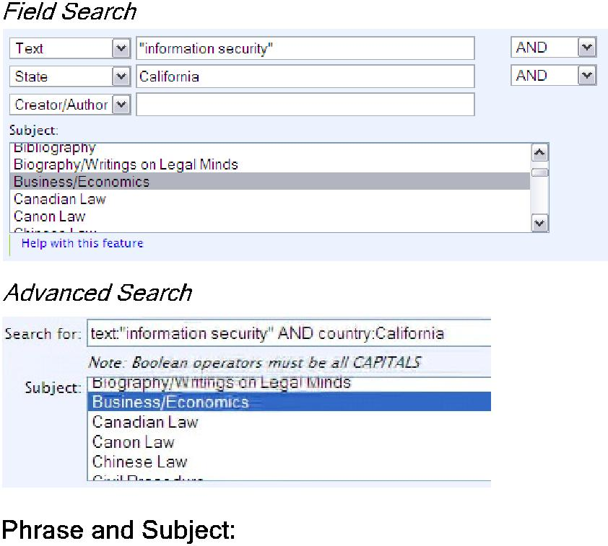

Search for “online privacy” across all titles associated with Intellectual Property.
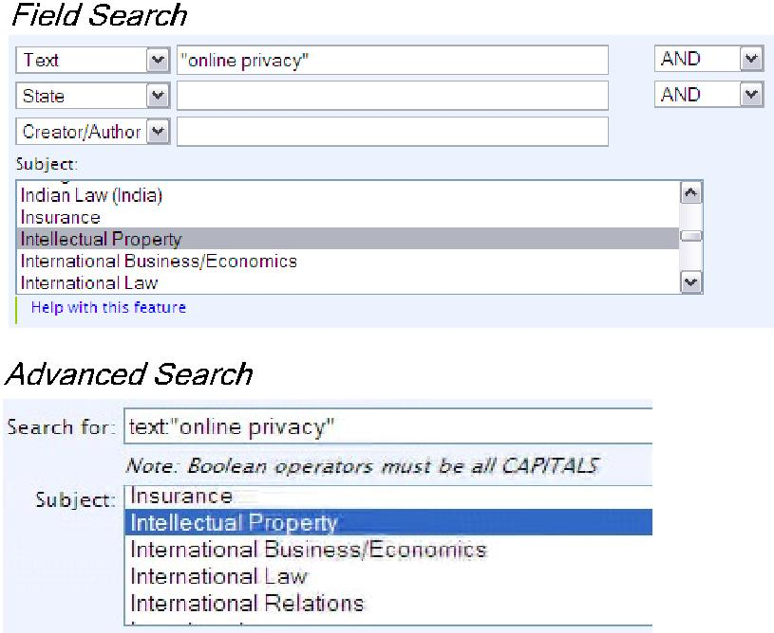

Search for “uniformity of laws” across all Australian titles.
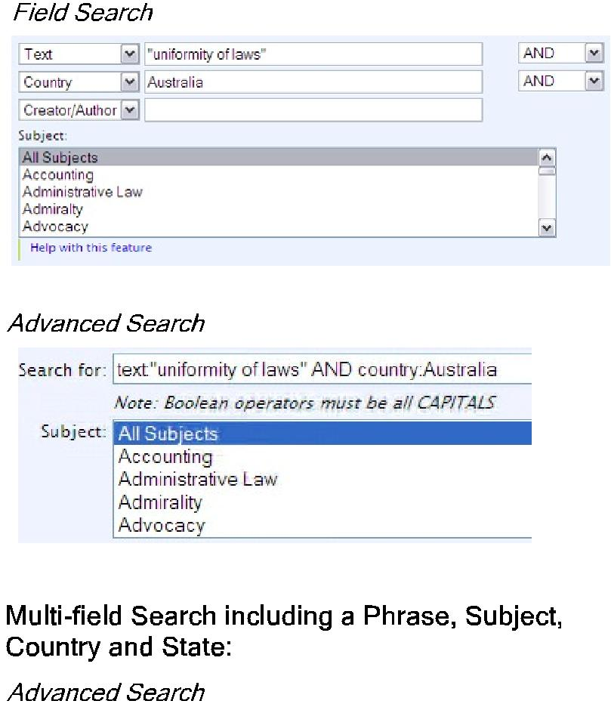

To conduct a search with more than three fields, you must use the Advanced Search option. Search for the term “private competition” across International Law Journals from California, New York, Canada or England. To do this, enter the following syntax into the search box:

text:”private competition” AND (state:California OR state:”New York” OR country:Canada OR country:England)

Then select International Law from the subject listing, and click search.

Tổng: 574 từ : 350 từ/trang = 1.64 trang

