

AALL 2012

- Quickly Access an Article or Document by Citation

  - Most libraries in HeinOnline have a citation navigator menu that allows a researcher to quickly and easily retrieve a document or article by citation.
    - Example (Law Journal Library):

      - If the Citation Navigator menu is not displayed on the left sidebar, simply click on the tab at the top of the screen.

      - You can enter the volume, journal citation and page number or you can copy and paste the Bluebook citation into the single citation box.
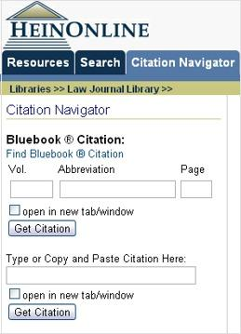
97 Geo. L. J. 1111

- As you begin to type the citation of the journal, an auto fill drop down menu appears allowing you to select the correct citation.

- If you do not know the Bluebook citation for the journal, click on the “Find Bluebook Citation” link, browse to the journal name and then insert the volume and page number.

Find Bluebook Citation
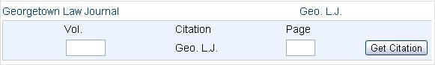

  - Some libraries have a custom citation navigator menu tailored to the content within that library.

    - For example, in the U.S. Statutes at Large library below the standard citation navigator, is a custom Public Law Number tool that allows you to quickly access a Statute by the Public Law Number.

      - Example:

        - For the 57th Congress forward, you can enter the public law number, such as 102-2.

        - For the 1-56th Congress’, you can enter the chapter and year of enactment, such as Chapter 4, Year 1937.

- Utilize the One-Box Search and Then Narrow the Search Results

  - When beginning your research with a keyword search, try using the one-box search to search across everything you are subscribed to.
  - Search example:

    - On June 28th, the Supreme Court ruled in a landmark decision and upheld the entire health care law by a vote of 5 to 4.
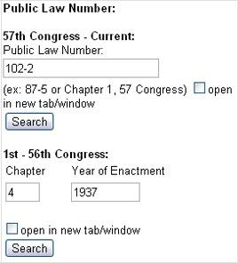
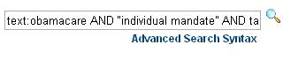
text:“obamacare”

  - The results will display facets allowing you to narrow the results by the collection/library, date, or type of document.

- The one-box search is essentially an advanced search box allowing you to utilize the advanced search syntax
- We can narrow our search further by modifying our search string to:
text: obamacare AND “individual mandate” AND tax



- How to Conduct a Subject Search

  - The best way to conduct a subject search in HeinOnline is by using proximity searching across the title and text fields using key terms that are related to your subject.

  - Example Subject:

    - In 2009 in the inaugural address, President Obama called for expanded use of renewable energy to meet the dual challenge of energy security and climate change. In a joint address to Congress on February 24, 2009, President Obama called for doubling renewable energy within three years and he restated this commitment in his 2012 State of the Union address.

  - Thus, let’s search for materials related to the discussion of renewable energy.

    - First, we want to identify key terms and subject related terms that we can use in our search string:
• Renewable energy |  | • Solar power
• Renewable resources |  | • Wind power
• | Climate change | • | Hydropower
• | Energy security | • | President Obama

NOTE: Since all the materials we will be searching across pertain to law, we don’t suggest including the term law in the subject search as it could mislead your results due to the reoccurrence of the term in the vast majority of content within HeinOnline.

- Now, we can create proximity searches across the text and title fields using these key terms.

  - Search string example:
text:”renewable energy climate change”~25 OR title:”renewable energy climate change”~25
- This will search for content that meets either of the above criteria.

- It will return results for documents that contain the terms renewable, energy, climate and change in the text of the document within 25 words of each other; or, it will return results for documents that contain those terms in the title of the document within 25 words of each other.

- If it finds content that meets both criteria (terms contained in the text and the title), the content is given a higher relevancy and placed higher on the search results list.

Additional tips for using and tweaking a proximity query when searching by subject:
- Only use words relevant to your search in the query.

- Leave out connector words (a, and, the, if, of, or, etc.) because these will dilute the results.

- If your search includes several words, increase the proximity range by increasing the proximity number after the tilde.
- If you try a search for the first time and get no results, increase the proximity range.

- If you try a search for the first time and get too many results, decrease the proximity range. Note: This may produce fewer results, but the results are likely to be more relevant to your research topic.

- Increasing the number of key terms used in a title search query can correspondingly decrease the likelihood of getting a relevant result because in some cases it can OVER limit the search by excluding articles that don’t have those specific words in the title. Therefore, be reasonable in the number of words you are using and try sticking to the key words for your topic.


AALL 2012

4. Four Key Techniques to Make the Most of Searching

For a detailed blog post about these four key techniques, visit Hunter’s Query, the Law Library blog from the J. Reuben Clark Law School at BYU, and look at a post entitled “Searching HeinOnline” written by Shawn Nevers.

- There are four key techniques that you can learn and understand to really make the most of searching in HeinOnline.
- These 4 key techniques include:
Understanding Boolean operators
• Boolean operators must be in all capital letters, such as AND, OR, NOT.
Using a root expander (wildcard searching) to find alternate endings
- Use an * to search for terms that match zero or more characters.

- Example: heate* (will find heater, heated, heaters)
Doing proximity searches
- The proximity symbol used is the tilde ~.

- Put the terms you wish to find within a certain proximity in a single set of quotations, followed by the tilde and the proximity number you wish to use.

- Example: “offshore drilling environment pollution”~25 (will find those four terms within twenty-five words of each other)
Boosting terms
        - Boosting allows you to influence the relevancy ranking of your results list.

        - If you are searching for three terms but want to place more importance and relevance on one of the terms, you can boost that term using the ^ symbol.
        - Example: obamacare AND "individual mandate" AND medicare^5

          - Our results will contain all three terms, but documents that contain medicare more frequently will be brought to the top of our results list.

- Use Hein’s ScholarCheck to View Cited Material

  - Hein’s ScholarCheck allows you to:

      - Analyze the most cited journals, articles, authors and more

      - View articles that have a heavy influence on the subject you are searching

      - View most-cited articles first

      - Link directly to cited material that is available in HeinOnline

  - What does Hein’s ScholarCheck do?

    - It links you to articles that cite the article or document you are reading

    - It indicates in your search results how many articles cite an article and provides a link to view the list of articles

    - It allows you to sort search results by the number of times an article is cited

    - With the Citations on a Page toggle feature, Bluebook citations to articles or documents that are available in HeinOnline will appear as a link, allowing you to quickly jump to the cited material

  - Where can you use Hein’s ScholarCheck?

    - Hein’s ScholarCheck is integrated throughout many HeinOnline libraries
    - To determine where ScholarCheck tools and features can be used, look for the ScholarCheck icon 

    - The next page illustrates how Hein’s ScholarCheck connects research together in a powerful way



AALL 2012

Tổng: 1463 từ : 350 từ/trang = 4.18 trang

E��������� ��� P���� �� H���O�����.

52 Stat.

1060
(1937)

Cites
Links &
to

 |  |  |  |  |  |  | l
 |  |  |  |  |  | ticei |  | n
 |  |  |  |  | r |  |  | n | H
 |  |  |  | A |  |  |  |  | H
 |  |  |  | d |  |  |  |  | H
 |  |  |  | d |  |  |  |  | e
 |  |  | e
 |  |  |  |  |  |  |  |  |  | i
 |  |  | t |  |  |  |  |  |  | n
 |  |  | i |  |  |  |  |  |  | O
 |  |  | C |  |  |  |  |  |  | O
 |  | t | C |  |  |  |  |  |  | n
 |  | t |  |  |  |  |  |  |  | l
 | o | s |  | Right to |  |  |  |  |  | i
M | o | s |  |  |  |  |  |  |  | n
M | o |  |  |  |  |  |  |  |  | e
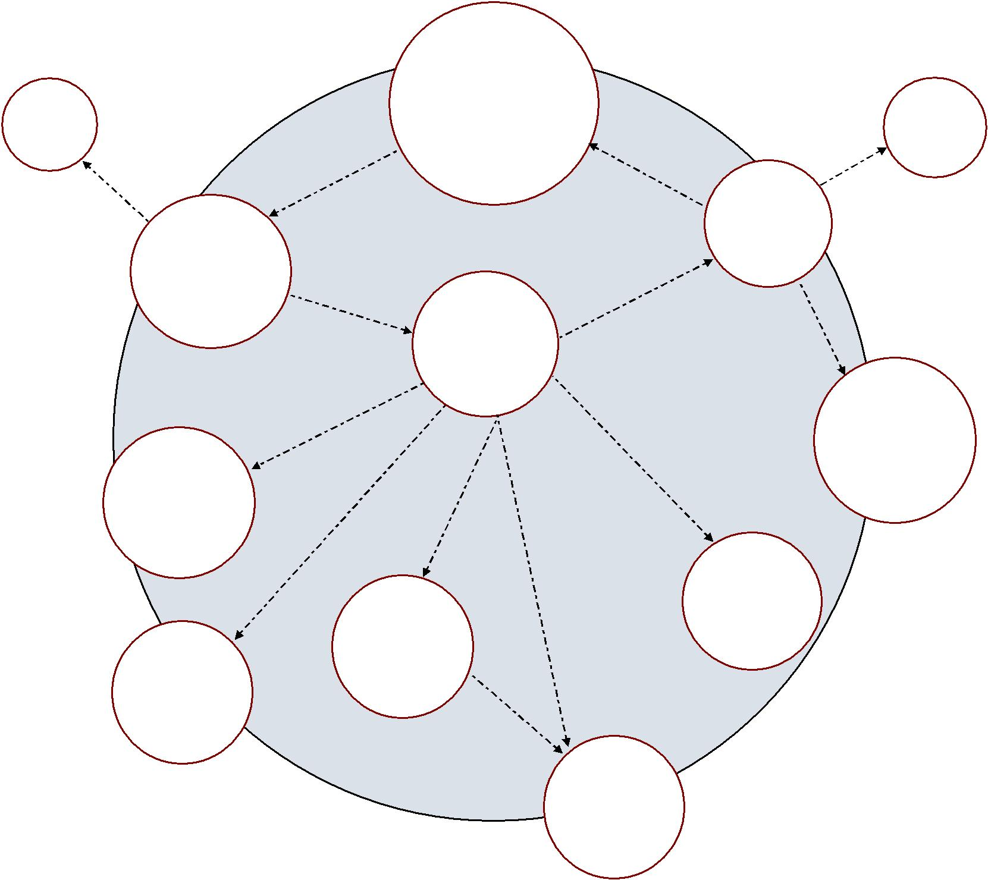
Privacy
4 Harv. L. Rev. 193

(1890-1891)
by Cited

Cites

 |  | 77 Eng.
& |  | Rep. 194
Cites | to | (1604)
Links
90 Cal. L.

Rev. 1087

83 Yale L.J. 221

(1973-1974)

Cites & Links to

by Cited to &Links

410 U.S. 113

(1973)
(2002)

Cites

4
Blackstone’s

Cites

Foster/Boast |  |  |  |  |  | by |  | to | Cites
 |  |  |  | Cited |  | by | Links | to
2.09 |  |  |  | Cited |  | by | Links
50-State Survey |  | Cites |  | Cited | & |  | Links
(1973) |  |  |  |  | &
 |  |  |  |  |  |  |  |  | Cites
 |  |  | 77 Mich. L.
 | 72 Selden |  | Rev. 1569
 |  |  | (1978-1979)
 | Society 60
 | Fleta, Book 1
 | (1953)
 |  |  | ALI Model
 |  |  | Penal Code
 |  |  | §230.3
 |  |  | (1985)

Commentaries

on the Law of

England 223

(1769)

NCCUSL

Uniform
Abortion Act

(1970)

